**Mustafa Ahsan Khan**

**I230549**

**CS_B**

Q1) The memory shows the contents in Little Endian format

|  |  |  |  |  |  |  |  |  |  |  |  |  |  |  |  |
| --- | --- | --- | --- | --- | --- | --- | --- | --- | --- | --- | --- | --- | --- | --- | --- |
|  | 01 | 02 | 03 | 04 | 05 | 06 | 07 | 08 | 09 | 0A | 0B | 0C | 0D | 0E | 0F |
| 0000 | 10 | 00 | 66 | 55 | 61 | 62 | 64 | 00 | 11 | 22 | 30 | 00 | 50 | 00 |  |
| 0010 | 60 | 00 | 70 | 00 | 80 | 00 | ? | ? | ? | ? | ? | ? | ? | ? |  |
| 0020 |  |  |  |  |  |  |  |  |  |  |  |  |  |  |  |

Q2) This is in Big Endian format

|  |  |  |  |  |  |  |  |  |  |  |  |  |  |  |  |
| --- | --- | --- | --- | --- | --- | --- | --- | --- | --- | --- | --- | --- | --- | --- | --- |
|  | 01 | 02 | 03 | 04 | 05 | 06 | 07 | 08 | 09 | 0A | 0B | 0C | 0D | 0E | 0F |
| 0000 | 10 | 55 | 66 | 61 | 62 | 63 | 64 | 00 | 11 | 22 | 30 | 00 | 50 | 00 |  |
| 0010 | 60 | 00 | 70 | 00 | 80 | ? | ? | ? | ? | ? | ? |  |  |  |  |
| 0020 |  |  |  |  |  |  |  |  |  |  |  |  |  |  |  |

Q3) 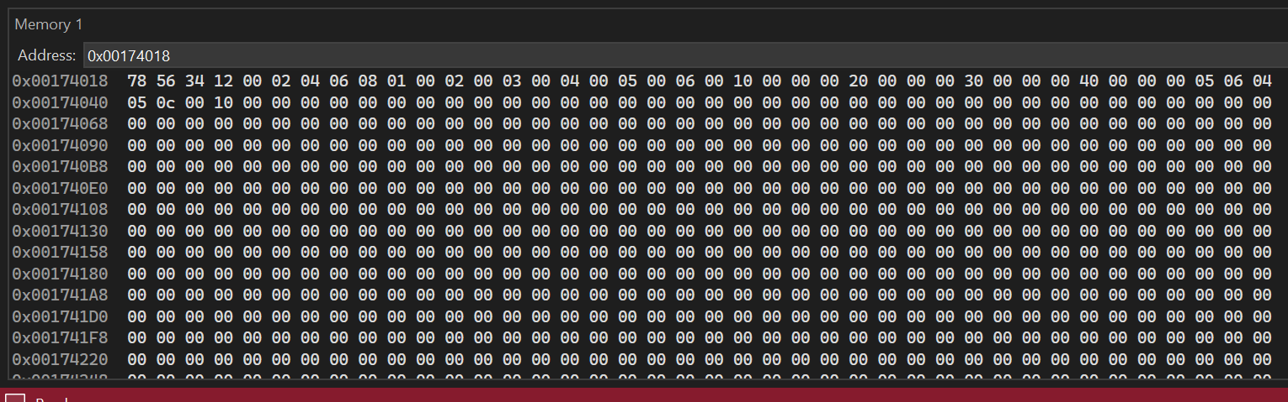

Q4) 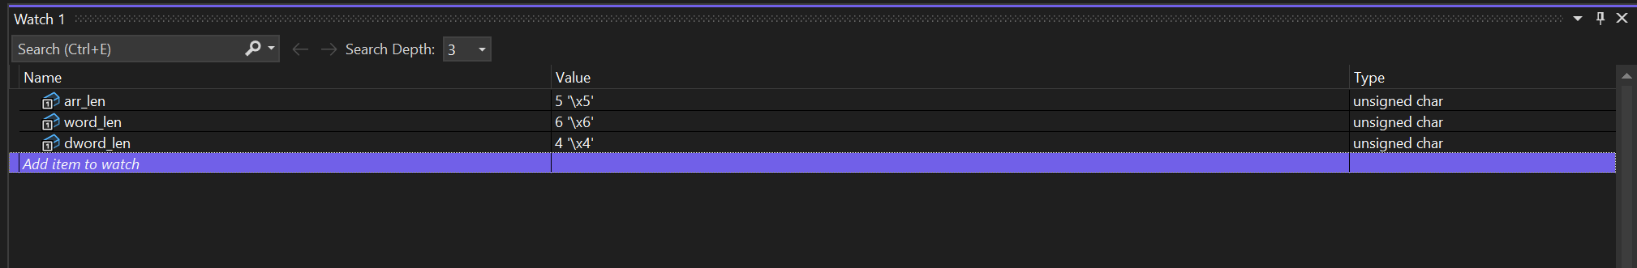

.386

.model flat, stdcall

.stack 4096

.data

comment @

; Q1

Var1 dw 010h

Var2 dw 5566h

Var3 dw 6261h, 64h

Var4 dw 2211h, 030h

Var5 dw 050h, 060h, 070h, 080h

Var6 dw ?, ?

Var7 dw 2 DUP(?)

@

; Q2

;Var1 byte 10h

Var2 dw 5566h

Var3 db 'abcd', 0

Var4 byte 11h, 22h, 30h

Var5 word 50h, 60h, 70h, 80h

Var6 db ?, ?

Var7 byte 4 DUP(?)

; Q3

Var1 dd 12345678h

; Q4

byte_Arr db 01h, 03h, 05h, 02h, 09h

word_Arr dw 00h, 01h, 05h, 03h, 09h, 08h

dword_Arr dd 10h, 20h, 30h, 40h

arr_len db ?

word_len db ?

dword_len db ?

;Q5

arr_Size db ?

word_Size db ?

dword_Size db ?

.code

main PROC

mov arr_len, LENGTHOF byte_Arr

mov word_len, LENGTHOF word_Arr

mov dword_len, LENGTHOF dword_Arr

mov arr_Size, SIZEOF byte_Arr

mov word_Size, SIZEOF word_Arr

mov dword_Size, SIZEOF dword_Arr

main ENDP

END main